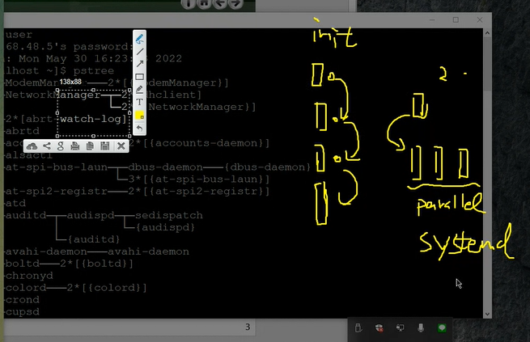

program vs. process

A process is a running program.

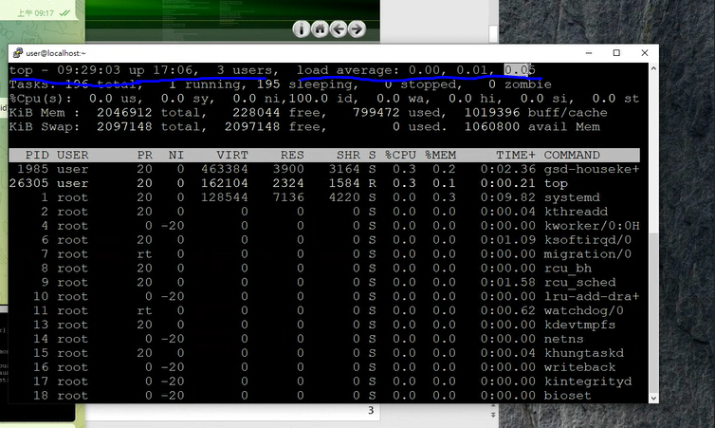

top uptime

//the total time of the computer is active

free -m

//to free the memory or unused process in the computer

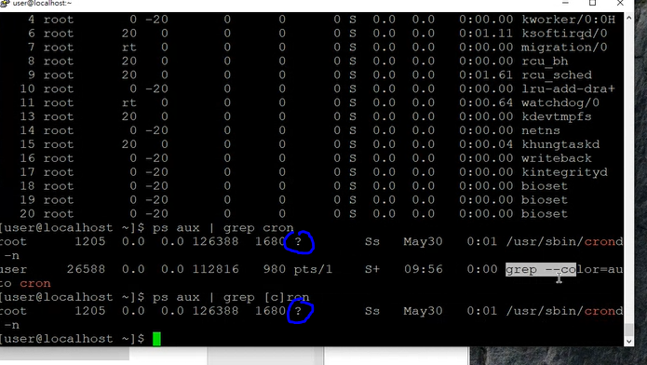

?

//means the process is running in the background

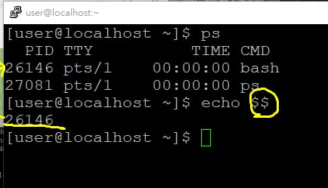

//to show the current process sign

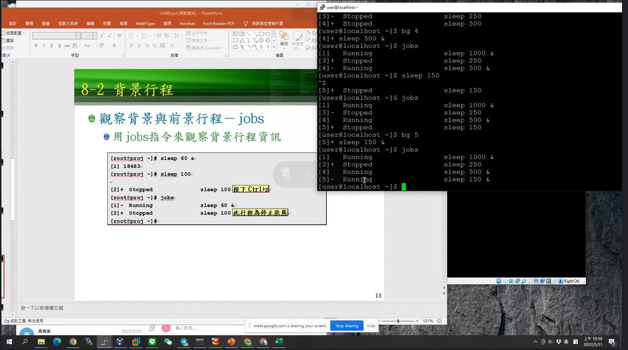

//Bg 5 is to pause the program running

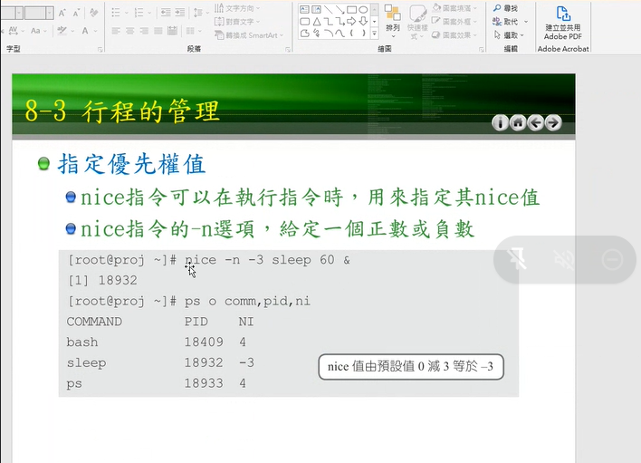

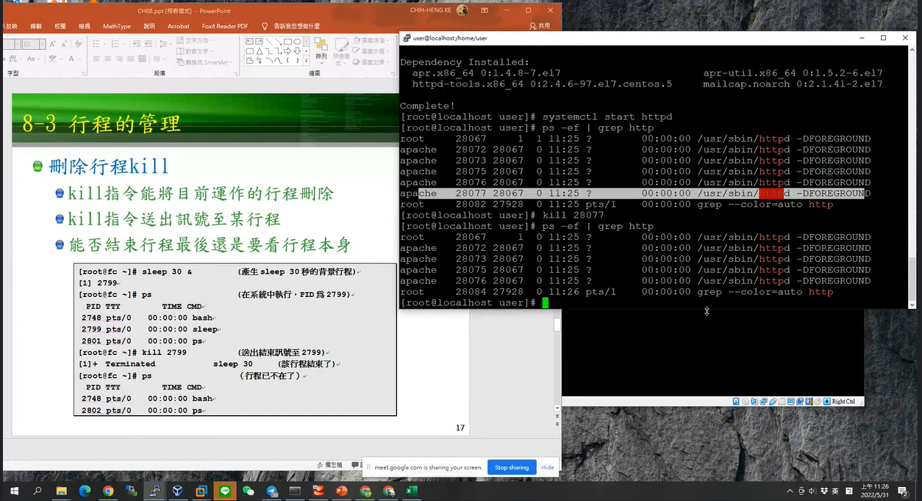

//kill process is to terminate all process

$$ is the process ID (PID) of the script